ETHICS SLIDE

Web scraping ~ abide by <https://en.wikipedia.org/wiki/Robots_exclusion_standard> robots.txt

**Web scrape of the numbers**

<https://www.the-numbers.com/> terms and conditions and stance of web scraping – No free API offered at a reasonable price through https://www.opusdata.com and there were no conditions against being able to scrap data required so we decided to scrape it- checked the privacy policy at

<https://www.the-numbers.com/privacy> and <https://www.the-numbers.com/about> unable to find any request against web scraping.

**Web scrape of rotten tomato’s**

Looking at <https://www.rottentomatoes.com/help_desk/licensing/> for determining if able to ethically use the data and web scrape they are only concerned with if you’re using the data for business uses such as implementing in other applications, nothing was mentioned about data analysis or request not to scrape the data, also checked parent company <https://www.fandango.com/policies/terms-and-policies> and https://www.fandango.com/policies/privacy-policy

**IMDB**

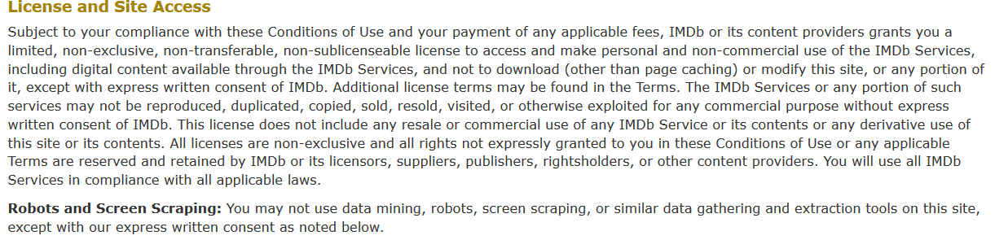

IMDB specifically advised that we are not to scrape the site without written permission, in this case we have found a third party api which has permission from IMDB <http://www.omdbapi.com/> through this we are able to request specific movies and there data through an API key

Links to omdbapi legal information <http://www.omdbapi.com/legal.htm> and licence <https://creativecommons.org/licenses/by-nc/4.0/>